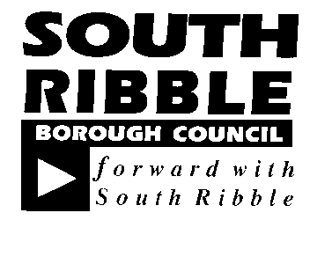  REPORT TO | ON
CABINET | 11 September 2019
TITLE | PORTFOLIO | REPORT OF
Naming of Penwortham Bypass | Planning Regeneration and City Deal | Director of Planning and Property

Is this report a KEY DECISION (i.e. more than £100,000 or impacting on more than 2 Borough wards?)  Is this report on the Statutory Cabinet Forward Plan?  Is the request outside the policy and budgetary framework and therefore subject to confirmation at full Council?  .  Is this report confidential? | No  No  No  No

PURPOSE OF THE REPORT

- To confirm the name of the Penwortham Bypass

PORTFOLIO RECOMMENDATIONS

- That Cabinet note the name of the Penwortham Bypass – to be announced at the meeting

REASONS FOR THE DECISION

- The Penwortham Bypass needs a name

CORPORATE PRIORITIES

- The report relates to the following corporate priorities:

Excellence and Financial Sustainability

Health and Wellbeing

Place | x

Projects relating to People in the Corporate Plan:

People

BACKGROUND TO THE REPORT

- Name suggestions for the Penwortham Bypass were invited from the primary and secondary schools close to the route of the new road.

- The Penwortham Bypass is a City Deal project and name suggestions were considered by a panel comprising: South Ribble Borough Council Leader, Broad Oak ward Councillor (Cllr Harry Hancock), Howick & Priory ward Councillor (Cllr David Howarth), LCC City Deal representative, LEP representative.

- The name was chosen on 29 August 2019.

PROPOSALS (e.g. RATIONALE, DETAIL, FINANCIAL, PROCUREMENT)

- The name suggestions were entered by schools as a competition, so to enable advising the winner and co-ordinating publicity the chosen name will be announced at the meeting.
CONSULTATION CARRIED OUT AND OUTCOME OF CONSULTATION

- The name ideas were suggested by local school children and ward Councillors were included in the process.

ALTERNATIVE OPTIONS CONSIDERED AND REJECTED

- Various options were considered to generate a selection of name suggestions.

Financial implications

- None

LEGAL IMPLICATIONS

- None
AIR QUALITY IMPLICATIONS

- None

Human Resources and Organisational Development implications

- None

ICT/technology implications

- None

Property and Asset Management implications

- The Penwortham Bypass will be maintained by Lancashire County Council with no implications for South Ribble Borough Council.

RISK MANAGEMENT

- None

EQUALITY AND DIVERSITY IMPACT

- None

RELEVANT DIRECTORS RECOMMENDATIONS

- That Cabinet note the name of the Penwortham Bypass – to be announced at the meeting

COMMENTS OF THE STATUTORY FINANCE OFFICER

- There are no financial implications.

COMMENTS OF THE MONITORING OFFICER

- There are no issues of concern to raise.

There are no background papers to this report
There are no appendices to this report

LT Member’s Name: Jonathan Noad
Job Title: Director of Planning and Property

Report Author: | Telephone: | Date:
Gill Beaghan, Communications | 01772 625201 | 20 August 2019

